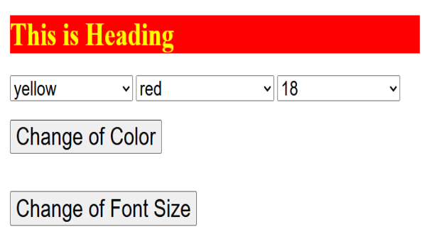

HTML Code
<!DOCTYPE html>
<html lang="en">
<head>
<meta charset="UTF-8">
<meta name="viewport" content="width=device-width, initial-scale=1.0">
<title>Change Heading</title>
<link rel="stylesheet" href="styles.css">
</head>
<body>
<div class="container">
<h1 id="heading">This is Heading</h1>
<div class="controls">
<select id="textColor">
<option value="yellow">yellow</option>
<option value="red">red</option>
<option value="blue">blue</option>
<option value="green">green</option>
<option value="pink">pink</option>
<option value="white">white</option>
</select>

<select id="bgColor">
<option value="red">red</option>
<option value="blue">blue</option>
<option value="green">green</option>
<option value="pink">pink</option>
<option value="white">white</option>
<option value="yellow">yellow</option>
</select>

<select id="fontSize">
<option value="18">18</option>
<option value="19">19</option>
<option value="20">20</option>
<option value="21">21</option>
<option value="22">22</option>
<option value="23">23</option>
<option value="24">24</option>
<option value="25">25</option>
</select>
</div>

<button onclick="changeColor()">Change of Color</button>
<button onclick="changeFontSize()">Change of Font Size</button>
</div>

<script src="script.js"></script>
</body>
</html>

CSS code
body {
font-family: Arial, sans-serif;
background-color: #f9f9f9;
display: flex;
justify-content: center;
align-items: center;
height: 100vh;
margin: 0;
}

.container {
text-align: center;
}

#heading {
background-color: red;
color: yellow;
font-size: 25px;
padding: 10px;
margin-bottom: 20px;
}

.controls {
margin-bottom: 20px;
}

select {
padding: 5px;
margin: 5px;
}

button {
display: block;
width: 200px;
padding: 10px;
margin: 10px auto;
cursor: pointer;
}

Javascript:
function changeColor() {
const textColor = document.getElementById("textColor").value;
const bgColor = document.getElementById("bgColor").value;

const heading = document.getElementById("heading");
heading.style.color = textColor;
heading.style.backgroundColor = bgColor;
}

function changeFontSize() {
const fontSize = document.getElementById("fontSize").value;

const heading = document.getElementById("heading");
heading.style.fontSize = fontSize + "px";
}

